CSA5103 – Cryptography and Network Security
Lab Experiments
Name: K. Teja Sri
Register No: 192525249

Exp.No:3

3. Write a C program for Playfair algorithm is based on the use of a 5 X 5 matrix of letters constructed using a keyword. Plaintext is encrypted two letters at a time using this matrix.

Aim:
To implement the Playfair Cipher using Python for encrypting plaintext with a 5 × 5 key matrix.

Algorithm:
- Enter the keyword and plaintext.
- Create a 5 × 5 matrix using the keyword.
- Split the plaintext into pairs of letters.
- Encrypt each pair using Playfair rules.
- Display the ciphertext.
Program:
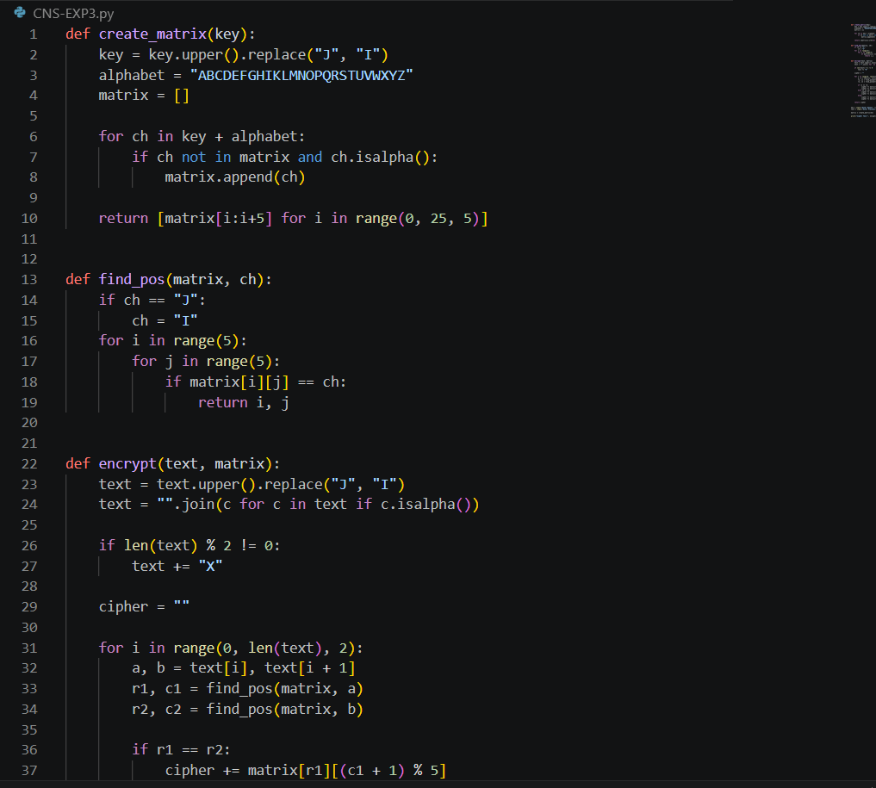

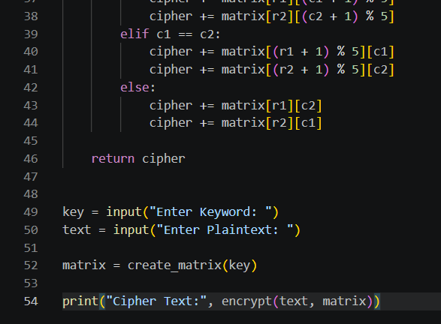

Output:
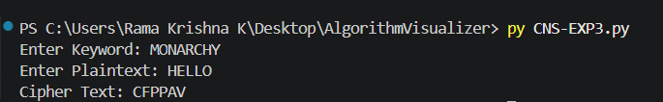

Result:
Thus, the Playfair Cipher was successfully implemented in Python and the plaintext was encrypted into ciphertext.

